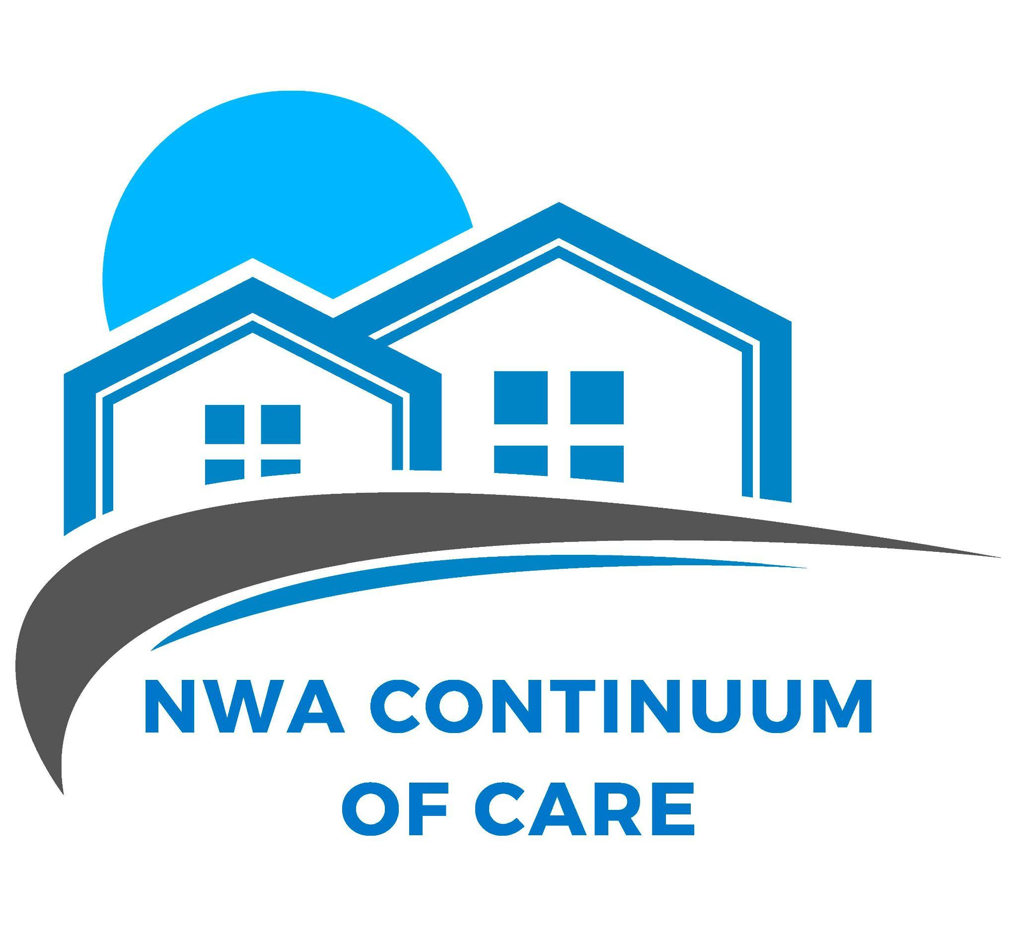

GOVERNANCE & BYLAWS OF NORTHWEST ARKANSAS CONTINUUM OF CARE, INC.

ARTICLE I: NAME
1.1 The name of the organization is NORTHWEST ARKANSAS Continuum of Care, INC., hereby referred to as NWACoC. NWACoC is a 501(c) 3 organization.

ARTICLE II: MISSION
2.1 The mission of the NWACoC is to coordinate a community response to end homelessness in Northwest Arkansas.

ARTICLE III: OFFICE
  - The organization maintains an official office in the State of Arkansas. The NWACoC is designated the Lead Agency of the continuum and is the organization responsible to maintain the organization’s records.

ARTICLE IV: MEMBERSHIP
  - Membership of the organization is open to homeless persons or formerly homeless persons, service providers, governmental representatives, civic organizations and individuals committed to increasing the availability and quality of services to persons or families who are experiencing or who are near homelessness.
  - Member organizations shall have one vote per organization in all matters requiring a vote. Individual members shall have one vote in all matters requiring a vote.
  - Limited membership fee waivers are available for individuals or organizations unable to pay the annual dues.
4.4 Paid or waived membership is required in order to serve on the NWACoC Board of Directors, to receive a letter of affiliation, apply for HUD funding, or receive NWACoC data. Membership benefits may be updated by the Board of Directors as necessary and shared with the membership.

ARTICLE V: BOARD OF DIRECTORS
5. 1 NWACoC shall be governed by a Board of Directors (hereinafter called “Board”) The Board shall formulate, implement, and monitor the policies of the organization in order to carry out its purpose. It shall be the policy of the Board to comply with all municipal, state, and federal regulations regarding the operations of the NWACoC and the Board.
  - NWACoC Board of Directors is responsible for developing policies and procedures in order to conduct the business of the Continuum. Policies and/or procedures shall be reviewed annually and include and/or guide operations in the following areas:
- Fiscal/Financial to ensure compliance with municipal, state and federal regulations that align with Generally Accepted Accounting Principles.
- Written standards for administering assistance.
- Community assessment and coordinated entry.
- Process for reviewing program performance for HUD CoC and HUD ESG funded programs as defined in 24 CFR 578.7 (a)(6) & (7);
- A process for developing agendas for NWACoC Board and General Membership meetings as well as policies regarding conflicts of interest and a board recusal process.
  - The Quorum of any Board meeting shall consist of a majority of the entire membership (in good standing) of the Board. A simple majority of those present shall decide any question that may come before the meeting.
  - The Board shall be comprised of no less than nine (9) and no more than twenty-one (21) directors. The tenure of the directors shall be limited to two 3-year consecutive terms. Efforts should be made to include representatives from each of the following areas:
    - Nonprofit homelessness assistance providers
    - Victim services providers
    - Faith-based organizations
    - Governments
    - Businesses
    - Advocates
    - Public housing agencies
    - School districts
    - Social services providers
    - Mental health agencies
    - Hospitals
    - Universities
    - Affordable housing developers
    - Law enforcement
    - Organizations serving veterans
    - Homeless or formerly homeless individuals

  - Election of Board of Directors: shall proceed as follows: Beginning in June, general members shall submit names of individuals for consideration by the Board. In August, a list of candidates will be submitted to the general membership. A regular annual meeting shall be designated for the purpose of electing new board members. The membership will vote by ballot, this may occur via paper or electronic ballet, and elected board members will begin their terms immediately after the tallying of the voting ballots. Once newly elected board members are selected, the board of directors will elect its own Officers including the At Large position.

  - Vacancies shall be filled in the following way: The Board may elect a new director to fill an unexpired term at any meeting. To fill Board vacancies, directors may submit names of members in good standing for consideration for temporary appointments to complete the unexpired term. The director who
was elected to fill the unexpired term may be considered for a full-term directorship when the unexpired term has ended. Additionally, directors filling unexpired terms may fill any committee or officer position immediately upon election as a new director.
  - Removal of a member of the Board may occur at any time, with cause or without cause, by a special meeting of the Board called expressly for that purpose.
  - Board members are required to attend all scheduled meetings. Absence from 3 (three) consecutive regular meetings of the Board, without prior notice to the Board Secretary and so recorded, may be construed as a resignation. A special meeting will not be necessary to validate a resignation.
  - Resignation by a director may be made by giving written notice to the Board Chair. The acceptance of such resignation shall not be necessary to make the resignation effective.
  - The Board shall meet at least quarterly on a date and at a time and place to be determined by the full Board.
  - The Lead Agency for the NWACoC will attend Board meetings but is a non-voting member.

ARTICLE VI: OFFICERS
  - Board Chair: The Board Chair shall be responsible for representing, promoting, and directing the operations and activities of the Board. The Chair shall act as the spokesperson of the Board, issue and request reports, recommendations from committees and committee chairpersons, and perform such duties as may be incidental to the office.
  - Vice-Chair: In the absence of the Chair, or in the event of the Chair’s death, inability or refusal to act, the Vice-Chair shall perform the duties of the Chair. The Vice-Chair shall perform such other duties as from time to time may be assigned to him/her by the Chair or by the Board. The Vice-Chair shall assist the Board in maintaining proper principles of governance in accordance with Robert’s Rules of Order.
  - Secretary: The secretary shall keep complete records of Board meetings, including an accurate record of attendance of members; notify the Board’s Executive Committee of any member dropped for non- attendance or other cause; mail such communications as may be directed by the Board, be custodial of all records of the Board; sign such papers as may be required by his/her office or as directed by the Board; and perform such other duties as may be incidental to the office.
  - Treasurer: The Treasurer will be responsible for all financial records and activities of the NWACoC, shall serve as the chair of the Finance Committee. Persons filling this office should have a good understanding of accounting and finance.
  - Officers are allowed one, two (2)-year term. After the expiration of the two-year term, officers may remain on the board with no time off.

ARTICLE VII: COMMITTEE STRUCTURE
  - The committee structure shall consist of the following standing committees: Executive, Finance and Coordinated Entry. All other committees shall be ad-hoc committees.
  - Standing and ad-hoc committees shall be appointed and abolished as necessary by the Board. Committees shall be filled voluntarily by the general membership or appointed by the Executive Committee. Any member of a committee may be removed by the Chair whenever, in his or her judgment, it is in the best interest of the organization is served by such removal. The committees shall ensure that minutes are prepared and forwarded to the Board Chair and Secretary, in addition to the members. Any expenditure of organizational funds by a committee requires prior approval of the Board. Each committee may adopt its own rules of procedure which shall not be inconsistent with the term of its creation or bylaws of the organization.

ARTICLE VIII: VOTING PROCEDURES OF BOARD
  - All business must be conducted officially by means of a vote taken at a meeting, by mail or by e-mail. Such matters must be decided by a majority of those voting unless otherwise specified.
  - A director of the Board may vote by absentee in the form of mail, e-mail or by proxy. Such voting by absentee or by proxy must be registered with any vote.
    - To vote absentee, a Board director must submit, in writing, by mail or email, a statement to the Chair or the Secretary specifying the specific matter(s) to be decided and the manner in which the director wishes to vote.
    - To vote by proxy, a Board Director must submit, in writing, by mail or email, a statement notifying the Chair of the person designated as proxy and the matter(s) in which the Board director wishes the proxy to consider.

ARTICLE IX: EXECUTIVE COMMITTEE
  - The Executive Committee shall have interim authority over NWACoC matters between board meetings and shall submit a report of action to the Board for ratification. Executive Committee meetings may be called as needed by the Board Chair.
    - The Executive Committee shall fulfill board governance duties and responsibilities, including, but not limited, to reviewing the governance structures and practices of the organization, and making recommendations to the board on governance policies, practices, and procedures related to the organization. Executive meetings serving this purpose may be called as needed by the Board Chair or Board Vice Chair.
    - The Executive Committee shall consist of the four (4) elected officers of the Board and one (1) other member appointed at large.
  - Special meetings of the Board will be called by or at the request of the Board Chair or by twenty percent (20%) of the directors in office. The person or persons authorized to call special meetings of the Board will fix the time and place for holding such meetings.
  - Notice of time, place and the purpose of all special meetings shall be given orally or in writing (to include email or facsimile) to each director. In case such notice is mailed, it shall be deposited in the United States mail in the place in which the principal office of the organization is located at least seven (7) days prior to the time of the holding of the meeting. In case such notice is delivered orally in person, by phone, facsimile or by email, it shall be delivered at least forty-eight hours (48) prior to the time of the holding of the meeting. Any actions taken or approved at any meeting of the Board of Directors, however called and noticed or wherever held, shall be as valid as though at a meeting duly held after regular call and notice, if a quorum is present.

ARTICLE X: FINANCIAL ACCOUNTABILITY
  - The fiscal year will begin on January 1 and end on December 31 of each year.
  - The Board may authorize any officer or agent to enter into any contract in the name of the NWACoC and on behalf of such authority may be general or confined to specific instances.
  - The NWACoC cannot enter into any indebtedness unless authorized by a resolution of the Board of Directors.
  - All checks, drafts, or other orders for the payment of money, notes, or other evidences of indebtedness issued in the name of NWACoC shall be signed by such officer or officers, agent or agents of the NWACoC, and in such manner as shall be determined from time to time by resolution of the Board of Directors.
  - All funds of the NWACoC not otherwise employed shall be deposited from time to time to the credit of NWACoC in such financial institutions as the Board may select.
  - The NWACoC will keep all records and provide access to those records at any time requested by the Board.

ARTICLE XI: AMENDMENTS
  - These Bylaws may be altered, amended, or repealed, and new Bylaws may be adopted by the Board of Directors at any meeting of the Board by an affirmative majority vote at which at least two-thirds of the Board is present, or represented by written proxy ballot. Bylaws will be reviewed every two (2) years.

ARTICLE XII: DISSOLUTION
  - In the event of the dissolution of NWACoC, all money in the treasury or any other assets on hand, after provision for its lawful charges and obligations, shall be distributed by the Board of Directors to another nonprofit organization in Arkansas that provides direct services to persons who are homeless and
/or near homeless.
  - Dissolution of NWACoC shall require at least two-thirds of the Board which is present, or represented by written proxy ballot. Board members must be notified in writing at least thirty (30) business days prior to said meeting at which time consensus will be reached on the decision for dissolution.

Signature of Board Chairperson Date

